Homework 2

Author: Shashank Garg

# Implement a majority class baseline

|  |  |  |  |
| --- | --- | --- | --- |
| Data | Precision | Recall | F-score |
| Training | 0.43275 | 1.0 | 0.604083057058105 |
| Development | 0.418 | 1.0 | 0.5895627644569816 |

# Word Length Baseline

|  |  |  |  |
| --- | --- | --- | --- |
| Data | Precision | Recall | F-score |
| Training | 0.6007401315789473 | 0.8440207972270364 | 0.7018976699495555 |
| Development | 0.6053511705685619 | 0.8660287081339713 | 0.7125984251968505 |

## Range of threshold tried

0 to max word length in the dataset provided

## Best Threshold:

7

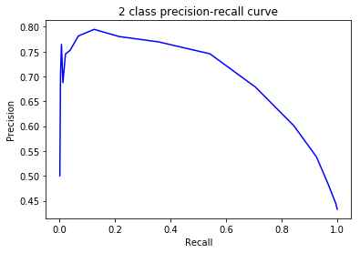

# Word Frequency Baseline

|  |  |  |  |
| --- | --- | --- | --- |
| Data | Precision | Recall | F-score |
| Training | 0.5640718562874252 | 0.8162911611785095 | 0.6671388101983002 |
| Development | 0.5559055118110237 | 0.8444976076555024 | 0.6704653371320038 |

## Range of threshold tried

0 to 1e+10 with step size of 1e+7

## Best Threshold

20000000

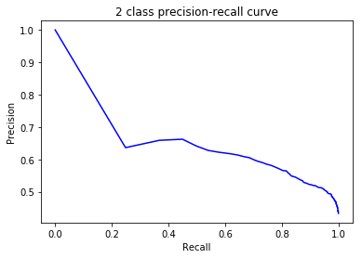

# Comparing Word Length Baseline with Word Frequency Baseline

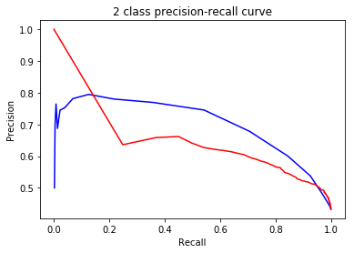

Red line indicates precision-recall curve for word frequency baseline model and blue line indicates precision-recall curve for word length baseline model.

Since area of the word length precision recall curve is greater than the area of word frequency precision recall curve, it can be suggested that the word length model is better than the word frequency model.

# Naïve Bayes

|  |  |  |  |
| --- | --- | --- | --- |
| Data | Precision | Recall | F-score |
| Training Data | 0.4950379451255108 | 0.9797804737146159 | 0.6577467519875897 |
| Development Data | 0.46929316338354576 | 0.9688995215311005 | 0.6323185011709602 |

# Logistic Regression

|  |  |  |  |
| --- | --- | --- | --- |
| Data | Precision | Recall | F-score |
| Training Data | 0.7250159134309357 | 0.6580011554015021 | 0.689884918231375 |
| Development Data | 0.7268170426065163 | 0.69377990430622 | 0.7099143206854344 |

The F-score of logistic regression model is higher than that of naïve bayes model for both the training data as well as development data. This indicates that the logistic regression model is expected to perform better than naïve bayes model on unseen data. One more observation to note from the results is that the recall of the naïve bayes model on both the training data as well as the development data is close to 1. This indicates that the naïve bayes model predicts majority of the word observations as complex words which is thus taking a toll on its precision.

# Build Your Own Model

## Features Used

1. Word Length
2. Word Frequency as given in Google n-gram frequency count
3. Syllables
4. WordNet synonyms

## Models Tried

* Random Forest

I tried to tune the following hyperparameters by using grid search:

* + Max_depth
  + N_estimators

I searched over the space of the depth of upto 12 and maximum esitmators of upto 1000. The best value was achieved at (max_depth, n_estimators)=(7,1000) and the following performance measure is reported:

|  |  |  |  |
| --- | --- | --- | --- |
| Data | Precision | Recall | F-score |
| Training Data | 0.8576086956521739 | 0.9116117850953206 | 0.8837860543265191 |
| Development Data | 0.7152173913043478 | 0.7870813397129187 | 0.7494305239179955 |

### Examples Correctly Classified

* + Unit
  + Chairwoman
  + Crippling
  + speed
  + color
  + syndrome
  + misbehavior
  + form
  + beige
  + crowded
  + proponents
  + unraveled
  + nutrition
  + pull
  + tanks
  + troubles
  + show
  + objected
  + desk
  + government
  + protein
  + embedded
  + gazing
  + whisked
  + believe
  + shuddering
  + safest
  + twirled
  + performance
  + stirred
  + unprecedented
  + gave
  + close
  + visionary
  + class
  + feeling
  + cousin
  + wrong
  + encourage
  + targeting
  + cattle
  + told
  + bald
  + going
  + purchasers
  + princesses
  + bristled
  + secret
  + overturned
  + minds
  + biomedical
  + coach
  + victims
  + muscle
  + epidemiologist
  + snapshot
  + talks
  + promoted
  + clinic
  + games
  + left
  + 4-May
  + proposal
  + worsened
  + astronomer
  + portable
  + otherworldly
  + commotion
  + promoting
  + narrating
  + next
  + incentives

### Examples Incorrectly Classified

* practically
* perpetrated
* patterns
* legacy
* elevator
* daughters
* majority
* beaver
* embrace
* cleanup
* eerie
* helicopter
* cookie
* behaviors
* pups
* attorney
* politicians

### Categories incorrectly classified

* Words whose length was in the range of 5-8 characters were misclassified more often
* Very long words such as self-imposed, elementary were also misclassified more.

# Optional Data Used

SemEval 2016 Dataset: http://alt.qcri.org/semeval2016/task11/